**Brooklyn torah gazette**

**For parshas bo 5780**

Volume 4, Issue 21 (Whole Number 173) 6 Shevat 5780/ February 1, 2020

**Printed L’illuy nishmas Nechama bas R’ Noach, a”h**

For a free subscription, please forward your request to [***keren18@juno.com***](mailto:keren18@juno.com)

**Why Was the Talmud**

**Called “Gemara”?**

**By**[**Yehuda Shurpin**](https://www.chabad.org/search/keyword_cdo/kid/15169/jewish/Shurpin-Yehuda.htm)



In a broad sense, Talmud (“study”) is the name for the vast collection of texts that covers the full gamut of Jewish law and tradition, compiled and edited between the third and fifth centuries.

There are two parts of the Talmud: the Mishnah, a collection of terse teachings written in Hebrew, redacted by Rabbi Judah the Prince; and a second part that includes elaborations on the Mishnah, citing many teachings, traditions and explanations of the rabbis ([read the full history of the Talmud here](https://www.chabad.org/library/article_cdo/aid/3347866/jewish/What-Is-the-Talmud-Definition-and-Comprehensive-Guide.htm)).

This commentary, known as “Talmud,” is labeled “Gemara” in classic editions of the Talmud, but this does not seem to have always been the case.

Furthermore, in many instances, the word *talmud*itself was removed from the text of the Talmud and replaced with *gemara*.[1](javascript:doFootnote('1a4617587');) Apparently, this was to avoid Christian censors, who hated the Talmud, which they perceived as a threat to their traditions.[2](javascript:doFootnote('2a4617587');)

Why was the word *gemara*used, and what does it mean?

**Meaning of the Word Gemara**

The Talmud tells us that the word *gemara* refers to oral traditions[3](javascript:doFootnote('3a4617587');) and study[4](javascript:doFootnote('4a4617587');). Rabbi Shlomo Yitzchaki, known as Rashi (1040-1105), explains that it connotes the teachings provided by later sages to elucidate and clarify the words of earlier sages.[5](javascript:doFootnote('5a4617587');) Elsewhere, he explains that it refers to the principles and underlying reasoning of the Mishnah and *halachah*, and how to resolve seeming contradictions in the Mishnah.[6](javascript:doFootnote('6a4617587');)

**The Talmud**

There seems to be only one clear instance in the Babylonian Talmud (and none in the Jerusalem Talmud) where the term *gemara* is used to refer to the body of the Talmud in general as it is used today.

At the conclusion of an incident in which a group of rabbis were discussing the laws of an *eruv* placed under a tree, the Talmud states:

Rav Nachman said to them: “Correct, and so said Shmuel.”

[The rabbis] said to him, “Did you analyze the Mishnah so thoroughly?!”

The Talmud explains: Why were they so amazed [that he studied thoroughly]? They too subjected the Mishnah to rigorous scrutiny. Rather, this is what they said to him: “Did you establish it in the *gemara*?”[7](javascript:doFootnote('7a4617587');)

[To which] Rav Nachman replied, “Yes, [I did].”

Although the term *gemara* seems to be used here in the conventional sense, it needs to be stressed that the Talmud had not yet been written at the time of this exchange. Rather, as Rabbi Sherira Gaon (c. 906-1006) explains in his famous epistle, during the generations of the Talmudic sages, when a teaching had become unclear due to the diminishing capacity of the students, they would establish the exact wording in carefully kept official oral records, which was called the *gemara*and later recorded as the Talmud.

Thus, the *gemara*was the official interpretation of the Mishnah accepted and sanctioned by the Talmudic academies of the time. However, the teachings and learning was all done orally. It was only later that it was all written down, as was done with the Mishnah years earlier.[8](javascript:doFootnote('8a4617587');)

This further supports the understanding that *gemara*originally referred to oral traditions and the act of repeating and learning them, not a written body of text.

**Deeper and Homiletic Meanings**

Some explain that the word *gemara* is related to the Hebrew word *gemar,* which means “finished” or “conclusion,” since it is the conclusion of the writing of the Oral Torah.[9](javascript:doFootnote('9a4617587');)

**Fiery Coal**

On a deeper level, some explain that the term *gemara* is rooted in the phrase *gumra de’asha,* a “fiery coal.”[10](javascript:doFootnote('10a4617587');) For when one learns Torah purely in order to serve G‑d, he ignites within himself a fiery passion.[11](javascript:doFootnote('11a4617587');)

**Protective Angels**

Rabbi Chaim Lowe (brother of the famed Maharal of Prague) explains that Talmud study is a form of spiritual protection. This is alluded to by the word *gemara*, which is an acronym for the four hosts of angels, each one headed by the archangels, who sing G‑d’s praise and surround the person to save him from harm:[12](javascript:doFootnote('12a4617587');)

**G**abriel גבריאל

**M**ichael מיכאל

**R**aphael רפאל

**U**riel אוריאל

May the merit of our Torah learning protect us all!

**FOOTNOTES**

[1.](https://www.chabad.org/library/article_cdo/aid/4617587/jewish/Why-Was-the-Talmud-Called-Gemara.htm" \l "footnoteRef1a4617587)See, for example, Talmud, Sukkah 28a, Bava Batra 8a.

[2.](https://www.chabad.org/library/article_cdo/aid/4617587/jewish/Why-Was-the-Talmud-Called-Gemara.htm" \l "footnoteRef2a4617587)Chanoch Albeck, Introduction to the Talmuds.

[3.](https://www.chabad.org/library/article_cdo/aid/4617587/jewish/Why-Was-the-Talmud-Called-Gemara.htm" \l "footnoteRef3a4617587)Talmud, Avodah Zarah 19a.

[4.](https://www.chabad.org/library/article_cdo/aid/4617587/jewish/Why-Was-the-Talmud-Called-Gemara.htm" \l "footnoteRef4a4617587)See, for example, Talmud Bava Metzia 33a-b.

[5.](https://www.chabad.org/library/article_cdo/aid/4617587/jewish/Why-Was-the-Talmud-Called-Gemara.htm" \l "footnoteRef5a4617587)Rashi on Talmud, Sukkah 28a.

[6.](https://www.chabad.org/library/article_cdo/aid/4617587/jewish/Why-Was-the-Talmud-Called-Gemara.htm" \l "footnoteRef6a4617587)Rashi on Talmud, Bava Metzia 31a.

[7.](https://www.chabad.org/library/article_cdo/aid/4617587/jewish/Why-Was-the-Talmud-Called-Gemara.htm" \l "footnoteRef7a4617587)Talmud, Eruvin 32b.

[8.](https://www.chabad.org/library/article_cdo/aid/4617587/jewish/Why-Was-the-Talmud-Called-Gemara.htm" \l "footnoteRef8a4617587)See Iggeret Rav Sherira Gaon, p. 73 of Mozanyim ed.; see also notes *ad loc.*

[9.](https://www.chabad.org/library/article_cdo/aid/4617587/jewish/Why-Was-the-Talmud-Called-Gemara.htm" \l "footnoteRef9a4617587)See Otzar Kol Minhagei Yeshurun, Marbim L’Hadlik Neirot in footnote.

[10.](https://www.chabad.org/library/article_cdo/aid/4617587/jewish/Why-Was-the-Talmud-Called-Gemara.htm" \l "footnoteRef10a4617587)See Targum Yonatan on [Exodus 27:5](https://www.chabad.org/9888#v5).

[11.](https://www.chabad.org/library/article_cdo/aid/4617587/jewish/Why-Was-the-Talmud-Called-Gemara.htm" \l "footnoteRef11a4617587)Rabbi Shlomo of Karlin, quoted in Beis Aharon, Seder Hayom V’azhorot, R’ Aharon (the second) 65.

[12.](https://www.chabad.org/library/article_cdo/aid/4617587/jewish/Why-Was-the-Talmud-Called-Gemara.htm" \l "footnoteRef12a4617587)Sefer Hachaim, Sefer Zechuyot 1:2.

*Reprinted from the Parashat Va’eira 5780 email of Chabad.Org Magazine.*

**The Shmuz onParshas Bo**

# **A Slave to Fashion**

**By Rabbi Bentzion Shafier**

**Founder of TheSmuz.com**

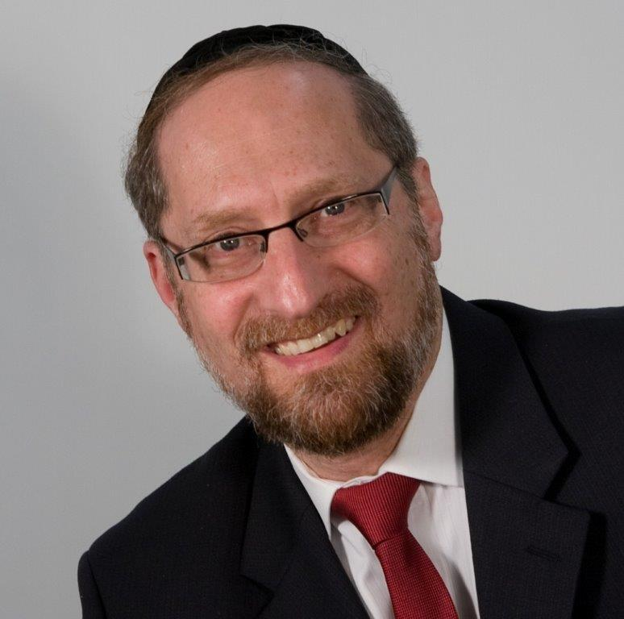

“*The Children of Israel did according to the word of Moshe; they requested from the Egyptian silver vessels, gold vessels, and garments*.” — Shemos 12:35

HASHEM promised Avraham that his children would be slaves in Mitzrayim, yet they would be redeemed and would leave with great wealth. And so, when it was time to leave Mitzrayim, HASHEM told Moshe to tell the Jews to borrow the silver and gold vessels of their Egyptian neighbors.

Interestingly, the Torah records that the Jews borrowed the silver vessels, gold vessels, and garments. Rashi explains that the order is progressive. To the Jews leaving Egypt, even more valuable than the silver and gold were the garments of the Egyptians. Therefore, while they weren’t commanded to ask for the garments, they did this on their own.

This Rashi is difficult to understand. These were highly intelligent people. They knew that HASHEM was fulfilling a promise made long ago. They knew they were to leave with great wealth, and they also knew the value of the objects involved. A shirt, a cloak, or whatever article of clothing is of limited value. With gold and silver vessels, they could buy whole wardrobes of such clothing. How is it possible that the clothing was more valuable to them than gold or silver?

The answer to this may be understood with an observation.

**Bowties and Bell-Bottom Pants**

If you look at your parents’ wedding album, you might find yourself wondering, “What were they thinking? The wild colors. The wide lapels. The strange haircuts. Didn’t they realize that people would look at them and laugh?”

Of course, the answer is that in those times, that look was “in.” That was the style. It was the way that fashionable men and women dressed. And the more fashionable they were then, the stranger they look now.

Whether bell-bottom pants, wide lapels, huge bows on the back of women’s dresses or rollers in their hair, each generation has a specific look that it considers appealing, and the vast majority of people kowtow to the demands of dressing fashionably as dictated by social pressure. It’s later on when the fashions have again changed that we look back and recognize how preposterous that old style was.

This seems to be the answer to this Rashi. The people leaving Mitzrayim were born into slavery. They were brought up in a world where the Egyptians were their rulers and masters. They viewed the Mitzrim as a superior class. And so, the clothing that their masters wore was that of the upper crust, something they couldn’t even dream of owning.

When the Jews were given the opportunity to take whatever they wanted, the most valuable thing to them was the clothing. Naturally, they understood that the wealth they were taking out could buy them many rooms full of such clothing, but nevertheless, they still desired those garments because in their world, this was coveted.

**A Slave Obeys**

This concept is very applicable to us. In the 1960’s, Western civilization underwent a cultural revolution. Norms and standards that had been accepted for generations were thrown away. The cry of the day was, “Do you own thing. If it feels good, do it. Throw away your inhibitions.” Established guidelines of conduct crumbled. Gone was decency. Gone was chastity. Gone was a sense of propriety and dignity.

We now live in the aftermath of that upheaval. Some of the collateral damage is an over fifty percent divorce rate, which makes the concept of children being raised in a stable home a relic of the past. And while as Jews we are somewhat apart from this, we are affected. One of the manifestations is the way that our young people dress.

**Regal in Appearance**

One of the most basic concepts that our yeshivahs teach is that the Jewish woman is a “daughter of the King.” Regal in appearance, bearing, and manner, she is not ordinary or common. She is a princess. And as a princess, she isn’t loud or showy in appearance. Our daughters aren’t showgirls or objects to be ogled. And so, naturally, their clothing, while attractive, should be modest and flattering as befitting royalty.

Yet, when we look at the picture of today’s weddings or bar mitzvahs, it’s not quite what we see. Seductive and suggestive is more like it, calling attention to the figure in a manner that asks that the wearer be viewed not as a person worthy of honor, but as an object of desire.

Naturally, this is the way of the times, and it seems to be normal — after all, isn’t everyone dressing that way? The real question is what future generations will say. “Oh, my goodness, look at Bubby! I can’t believe it! Wasn’t she embarrassed to go out in public like that? And Zaidy didn’t say anything? I mean, I hate to say it, but she looks like… I mean… ummmm…”

The sad reality is that we have become slaves to the whims and fancies of people who do not share our understanding of the holiness of the individual, nor the greatness of the human. Our “fashion gods” who sit in Paris and London dictate their edicts upon us.

Throw out all of last year’s clothing — that’s passé, unacceptable, no longer in. Pointy shoes? Unforgivable. Wedged toes are the latest thing. Banish thy colored clothing and adorn thyself only in black. Modesty? Please. That’s so old school. Get with the times. And like despots of old, the designers sit in the fashion cathedrals of Sixth Avenue and decree style — and we dutifully follow.

But what can we do? How can we educate the next generation? We need to focus on dignity and self-worth. While clothing may not define the person, if you dress like a plumber, people expect you to change pipes. And if you value your dignity and self–worth, you dress appropriately.

We are an exalted and holy people. We are expected to be a chosen nation, respected amongst the nations. And as such we aren’t slave to any man, notion or fashion — we serve only one G-d. We need to recognize our role in the world and dress the part.

*Reprinted from this week’s website on TheShmuz.com This is an excerpt from the [Shmuz on the Parsha book](https://theshmuz.com/product/shmuz-on-the-parsha-book/).*

**Sages through the Ages**

**Rav Meir Shapiro**

**Suceava, Austria-Hungary 1887 - Lublin, Poland 1933**

**By Dr. Benji Schreiber**

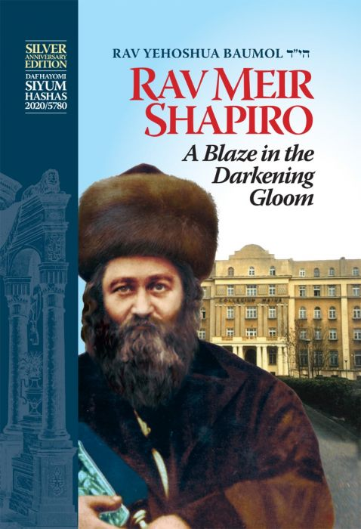

Rav Yehuda Meir Shapiro was born in Shotz (Suceava, now in Romania). He learnt Torah from his maternal grandfather, who wrote the Minchas Shai (Rabbi Shmuel Yitzhak Schor).

One of his early teachers was Rav Shulem Moshkovitz zy’’a, known as the Shotzer Rebbe, who came to Stamford Hill before WWII, died in 1958 and is buried in Enfield. Another important influence for him was Rav Yisroel Friedman, the second Chortkover Rebbe (1854-1934).

He married Rebbetzin Malka Toibah and was Rov in Galina, Sanok and then Piotrków before being appointed in 1931 as Rav of Lublin in what had been the shul of the Maharshal (1510-1573) many years earlier.

**Political Roles**

He was a founding member of Agudas Yisrael and, in the years 1922-1927, he represented them as the first Orthodox Jew to become a member in the Sejm (Parliament) of the Second Polish Republic representing the Jewish minority of the country. In 1928 he stepped down from this role so that he could devote all his energies to Yeshivas Chachmei Lublin.

[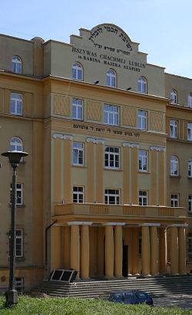](https://en.wikipedia.org/wiki/File:Jeszywas_Chachmei_w_Lublinie.JPG)

[**Chachmei Lublin Yeshiva**](https://en.wikipedia.org/wiki/Chachmei_Lublin_Yeshiva)**.**

**Daf Yomi**

Rav Shapiro introduced the revolutionary idea of a coordinated Daf Yomi programme at the First World Congress of the World Agudath Israel in Vienna on 16 August 1923, saying: “Imagine a Jew from Eretz Yisroel travelling with a gemara Brachos under his arm, going to the United States for two weeks. While he’s there he goes into a Beis HaMedrash and finds Jews learning the same daf, and he happily joins them and can discuss it with them and Hashem’s name is glorified.”

Thanks to him, tens of thousands now learn the Daf Yomi, and over 300,000 participate in siyumei haShas worldwide, a wonderful unifying factor for Orthodox Jewry.

**Yeshivas Chachmei Lublin**

He conceived of a yeshiva for Chassidic Poland, modelled on Lithuanian yeshivas such as Volozhin, Slabodka and Novardok, but which would train Chassidic Rabbonim as the next generation to lead Polish Jewry. The cornerstone was laid in 1924 in a ceremony attended by 20,000 people, and the Yeshiva opened in 1930. He was Rosh Yeshiva until his petira.

The Yeshiva was housed in a massive building, with hundreds of students and a vast library of over 100,000 seforim, which were tragically burned in the town square by the Nazis in 1940 in front of the Jews of the town while a brass band played to drown out their cries. Composer He composed several songs, including אם רגלי מטה אמרתי which was recently sung by a well-known Israeli singer. The story goes that he was pained by the poverty of his talmidim and went collecting, but couldn’t even raise enough to cover the expenses of the trip. He then composed the first, sad part of the song. The next day an anonymous wealthy donor came and, rejoicing, he composed the second, happy part. His best known song is עוצו .עצה ותופר Petirah Rav Shapiro became ill with typhus (today cured with antibiotics) in 1933 and died within the month at the age of 46. At his death bed, he could not speak, but he signalled to his talmidim to drink l’chaim and they danced to the song he composed, אבותינו בטחו בך ,in you our forefathers trusted. His petirah was mourned in both Jewish and non-Jewish Poland. Countless newspapers across the entire political spectrum, whether Orthodox, Yiddishist or socialist, featured front-page biographies of Rav Meir Shapiro. He was reburied on Har Hamenuchos, Yerushalayim, in 1958. Legacy Rav Meir Shapiro had no biological children, however he used to say that he actually had two children – Yeshivas Chachmei Lublin and the Daf HaYomi.

*Reprinted from the Parashat Shemos 5780 email of Oneg Shabbos (London, United Kingdom).*

**The Dangers of Wealth**

**By Rabbi Eli J. Mansour**

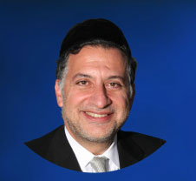

Before Benei Yisrael left Egypt, G-d tells Moshe, "Please speak to the nation that they should each borrow from his fellow…silver and gold utensils" (Shemot 11:2).

Moshe is to instruct the people to borrow property from their Egyptian neighbors which they will take with them as they leave Egypt. After over two centuries of slave labor, it was time for Benei Yisrael to receive their due payment from the Egyptians, and G-d therefore bid them to go to their neighbors who, He assured them, would happily give them their money and possessions.

Many commentators noted the seemingly peculiar word "Na" – "please" – in this verse.  It sounds as though Moshe had to plead with the people to borrow their neighbors' possessions.  Why would have to plead?  Wouldn't the people relish the opportunity to seize the wealth of their former oppressors?

Furthermore, why did G-d have Benei Yisrael seize the Egyptians' wealth in this manner, by asking to "borrow" their possessions?  Moshe had already brought nine devastating plagues upon Egypt; the Egyptians were already intimidated.  Would they have refused Benei Yisrael's request that they give them gold and silver utensils?  Why didn't they ask in a more straightforward manner?

One explanation is that Benei Yisrael feared the consequences of acquiring wealth.  This marked the first time that Benei Yisrael as a nation became affluent, and they perceptively understood the spiritual challenges that affluence poses.  Wealth is a privilege and a blessing, but it can often lead to arrogance and conceit.

Affluent people often regard themselves with greater importance than others, and assume the right to force their will upon the less privileged and to exert control and power.  To Benei Yisrael's credit, they initially hesitated when the time came to seize the property of Egypt; they feared the potential impact that their newfound position of affluence might have upon their characters and souls.  Moshe therefore had to plead with them to obey G-d's command and take their neighbors' possessions.

But how did Benei Yisrael protect themselves from the arrogance and egotism that often results from affluence?  How did Moshe assuage their legitimate concerns?

Moshe advised the people to borrow, rather than just ask to keep, their neighbors' possessions.  A person who borrows expensive items cannot feel pride over what he has, because he knows it does not belong to him.  If a person rents a luxury car, he can't show it off or gloat, because he will soon have to return it.  This was the solution to Benei Yisrael's ambivalence towards their acquisition of wealth.

And this is the proper response to the challenge of wealth generally: to look upon what a person has as borrowed goods.  When a person realizes that money has wings that all his wealth could be taken from him at any time, his ego is tempered; he cannot feel too proud or confident.

This is the proper perspective with which to look upon one's possessions: as borrowed goods.  Nothing in life is guaranteed, and there is no telling when our belongings will be taken from us.  This perspective will help us avoid the pitfalls of wealth, and maintain the proper sense of humility even as we enjoy the comforts and luxuries of American society.

*Reprinted from this week’s website of the Edmond J Safra Synagogue of Brooklyn website.*

**Thoughts that Count for Parshat Bo**

*And Moses said, With our young and with our old we will go* (Exodus 10:9)

Moses mentioned the children before the elders as the need to remove them from Egypt's corrupting influence was more urgent.

The young were in greater danger than the older generation, who were already firmly rooted in their Judaism. (Daat Chachamim)

*Reprinted from the Parashat Bo 5755/1994 edition of :L’Chaim Weekly.*

**Rabbi Berel Wein on**

**Parashas Bo**

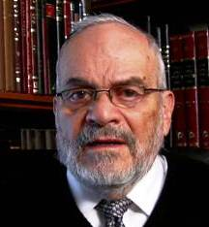

The Torah reading of this week begins with the Hebrew word ‘bo.’ This word literally means to enter. Normally, if we wish to describe crossing a threshold to appear before a person, the word ‘bo’ is not usually the verb that is used. To enter, in this instance, means to delve into the personality and the mind of the person, – to enter the conscience of that person, so to speak.

So, why does the Torah use this verb ‘bo’ in connection with Moshe, appearing once again before the Egyptian Pharaoh, in order to tell him that he should liberate the Egyptian slaves and allow the Jews to live as free people outside of the land of Egypt?

I think the insight into this can be found in the words that the L-rd imparted to Moshe. The L-rd tells Moshe that he should be aware that his words will have no effect on the Pharaoh, and that the Pharaoh will not allow the Jews to be released from their bondage in Egypt.

It appears Moshe is sent on a mission of futility, with the sole purpose to somehow change the mind and heart of the Pharaoh and allow him to free the Jewish people by sending them forth from his country as an independent nation. If this is the case, and it seems obvious that it is, then the entire conversation between the L-rd and Moshe leaves us wondering as to what its purpose is, what is its import and reason. What are we to learn from it?

I believe that the insight necessary to understand this conversation lies in the fact that G-d tells Moshe that Heaven has hardened the heart of Pharaoh, i.e. that Pharaoh is now incapable of making the correct choice for his own salvation and the salvation of his people. The Talmud teaches us that people who are completely evil, based on previous behavior and actions, are incapable of repenting and choosing wisely, even when they stand on the precipice of hell itself.

We are witness to the fact that many times in life people, usually very bad people who previously had the opportunity to repent and do good, find themselves trapped by their very nature. Though these are circumstances that they have brought upon themselves, even though they are aware that their policies and behavior may be suicidal in nature and harmful to them in the extreme, they are unable to prevent themselves from falling into the abyss that they themselves have created by their stubborn mindset.

The L-rd tells Moshe that this is the case regarding Pharaoh. He is unable, even if he wanted to withdraw from the situation that he himself has entered, through his previous behavior and decisions. His greatest advisors have told him that he is destroying Egypt and himself. Yet Pharaoh is unable to regain his sense of balance and make the wise choice that will save the lives of thousands of Egyptians and himself as well.

So, the L-rd told Moshe, ‘bo’- enter into his mind, and when you are able to do so, you will appreciate that Pharaoh is not going to be able to save himself. This lesson, regarding human stubbornness and futility, is the reason that the Torah uses the verb ‘bo’ when referring to the conversation and narrative that introduces this week's Torah reading.

*Reprinted from the Issue #345 of L’Chaim Weekly (Parashat Mikeitz 5755/1994)*

**Rav Avigdor Miller on**

**The Inferiority Complex**

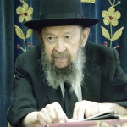

**QUESTION:** There’s a frum boy who suffers from an inferiority complex. What should he do about it?

**ANSWER:** I don't know exactly what you mean by that, but you do have to know the following: An inferiority complex is nothing wrong at all – he should be happy with it. If you feel inferior, that’s wonderful - you're an anav [humble person).

The only trouble is if you're unhappy with it; if you're unsatisfied with the inferiority complex, then you’re not an anav. You really want kavod [honor and glory]; you'd like to be a blustering gibor [hero], that everybody should look up to you and praise you, and it hurts you that you don't have the boldness.

That kind of inferiority complex you’re asking about? So we say, learn mussar and learn how silly it is, how useless it is to be a bigshot. Learn mussar and you’ll realize how lucky you are that you're a baishan, a bashful fellow. בושת פנים לגן עדן – If a person is bashful, he's a candidate for Gan Eden (Avos 5:20).

Do you know how many sins he is spared? It’s the fellow who is bold and not ashamed, that’s the one who can fall into every kind of aveirah [sin], every temptation. But a man who is bashful, he is protected from very many temptations.

TAPE # 502

*Reprinted from the January 12, 2020 email of Toras Avigdor adapted from Tape #502.*

**Daily Torah Advice for a**

**Son in the Israeli Army**

**By Daniel Keren**

(Armed with Spirit: A Father’s Advice to His Son in the Israeli Army Based on the Weekly Torah Portions” by Rabbi Shalom Hammer, 264 pages (paperback), 2019, Gefen Publishing House, Jerusalem)



Ever since the early years of the State of Israel there has been a tension between the mainly secular Jews whose sons and daughters have been drafted into the Israeli Army (IDF) and the ultra-Orthodox Jews who have demanded and gained exemptions for their sons who are learning in yeshivos and for their daughters who they feel should be shielded from the threats of a non-religious environment posed by service the IDF.

And then you have the Modern Orthodox or Religious Zionist community that has argued for the creation of special Hesder military units for their sons and for the option of national service for their daughters that would allow young religious ladies the option to serve in schools, hospitals and other civilian venues also to avoid the danger of being in a spiritually uncomfortable environment. It must also be noted that some Religious Zionist young ladies have specifically chosen to serve in the IDF, although that is not the usual.

The basic argument of the Chareidi or ultra-Orthodox community is that by learning in yeshivos, their young men are just as effective as military combat soldiers in protecting the Jewish nation because of the importance of Torah learning and after all it is a basic assumption taught by Chazal (our Sages of blessed memory) that Hashem created the world based on the premise that the Jews would accept the Torah at Har Sinai and continue to faithfully study the Torah until and even after the coming of Moshiach that we all pray for three times a day.

On the other hand, the secular (yet-to-become Torah observant) Jews that are still the majority in Israel today believe that the Orthodox Jews who don’t serve in the IDF are shirking their moral responsibility.

Gefen Publishing House has just published excerpts of the daily Torah messages that Rabbi Shalom Hammer, a Religious Zionist Jew living in Israel emailed to his son Yakov during his almost three years of draft service in the IDF beginning in August of 2015 based on the weekly Torah Portions.

Born in Queens, New York, Rabbi Hammer grew up in Monsey, NY where he became very close to Rabbi Berel Wein who has written a foreword to “Armed with Spirit.” After graduating from the Marsha Stern Talmudical Academy, he went on to study at Yeshivat Kerem B’Yavneh in Israel for two years before enrolling at Yeshiva University where Rabbi Hammer earned a degree in speech and also obtained smicha (rabbinical ordination) from Rabbi Herschel Schachter.

Rabbi Hammer has served as a rabbi in the IDF. In 2014 he founded the Makom Meshutaf organization that gives lectures on the importance of Jewish identity to secular kibbutzim throughout Israel.

Obviously Rabbi Hammer realized that his son Yakov was in very serious potential spiritual danger when after being drafted he was assigned to the Nahal Brigade Battalion 50, an IDF military unit of whom the majority of the battalion members come from non-observant members of the very left-wing Shomer Hatzair kibbutz movement.

Rabbi Hammer therefore felt compelled to email his son Yakov daily Torah messages that were also intended to highlight the importance of Yaakov’s service in the IDF. As he writes in the Preface to “Armed with Spirit”:

“Army service in the IDF was a minium of 32 months at the time, and while we were supportive of Yakov and where he chose to serve, I knew there were religious challenges to come. From the very first day of his service, I promised him, and perhaps more so myself, that every day I would send him a dvar Torah (a world on the Weekly Torah portion or parshah) message on his WhatsApp.

From Rabbi Hammer’s emails to Yakov one can detect that he was exceedingly proud of his son’s commitment to the IDF and told Yaakov almost daily how important that service was to his fellow Jews and citizens in the Jewish State.

“Armed for Spirit” also includes feedback from Yakov to his father’s emails. Interestingly enough the strain of accommodating the legitimate needs of the religiously observant chayalim (soldiers) of the IDF are revealed in one of Yakov’s replies to his father’s email.

In Parshas Noach (October 15, 2015, page 33-34) Yakov writes:

“Thank you for your inspirational words, Abba.

“Unfortunately the two institutions that I know are crucial often conflict with each other. For example, as a religious soldier, I have extra time in the morning to daven Shacharit, but while I do so, the secular soldiers in our division have to prepare the equipment for the day’s maneuvers and training, which takes them longer because we (observant soldiers) are not there to help.

“They do not say anything, but I have a strong feeling this does not sit well with our secular comrades. These are some of the challenges we knew we would have to deal with as religious soldiers in a mixed unit, challenges that a beinish (bnei yeshivot) Hesder yeshiva unit does not have because they do not have to deal with these sensitive situations as much as we do.

“I remain committed to my davening and to serving Hashem as best I can, but I must put in extra effort during the course of the day to demonstrate to my fellow soldiers my concern for them and for the duty at hand.”

“Armed with Spirit” by Rabbi Shalom Hammer offers an interesting inside look at an important aspect of the struggle of a religious soldier to be loyal to both the Torah that we Jews accepted from Hashem at Mt. Sinai while also being an effective chayal in the IDF. This book should be available in most Jewish bookstores or by contacting the publisher by calling (516) 593-1234.

*Reprinted from the January 17, 2020 edition of the Jewish Connection.*

**Thoughts that Count for Parshat Bo**

*We do not know with what we will serve G-d until we arrive there* (Exodus 10:26)

We cannot appreciate the value of a life of Torah and mitzvot "until we arrive there" -- until we are in the World to Come. Only then will we understand the full significance of our service in this world. (The Gerrer Rebbe)

*Also the man Moses was very great in the land of Egypt, in the eyes of Pharaoh's servants, and in the eyes of the people* (Exodus 11:3)

It is very unusual for a person to be well-liked by both the nobility and the common folk. Ordinarily, an individual who is popular among one class is scorned by the other, for each group has different criteria by which they pass judgment.

Moses' greatness was reflected in the fact that he was respected "in the eyes of Pharaoh's servants" -- the ministers of Egypt's upper class -- as well as "in the eyes of the people." (HaDrush VeHa'iyun)

Reprinted from the Parashat Bo 5755/1994 edition of :L’Chaim Weekly.

**The Difference Between Auschwitz and Jerusalem**

**By Rabbi Yosef Bitton**

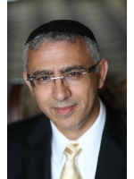

More than 40 world leaders gathered in Jerusalem to honor the victims of Nazi extermination, on the 75th anniversary of the liberation of the Auschwitz-Birkenau concentration camp.

Question: What is the most important part of this title?

Why? The world’s leaders converged in Jerusalem, in what was the largest diplomatic event in the history of the State of Israel. But some leaders were not there. I do not mean the leaders of Iran or the Arab countries. I mean Poland.

The Polish government wanted the commemoration of the Liberation of Auschwitz- where 1.1 million Jews were killed- to take place in Auschwitz. Auschwitz is located in the district of Oswicim, which is Polish territory. In Oswicim there are many monuments as well as a very significant place: the Auschwitz-Birkenau State Museum where according to the Polish government the ceremony should have been held.

What is the difference between celebrating the liberation of Auschwitz in Auschwitz or in Yad Vashem, Jerusalem?

The ceremony at the Auschwitz museum would have been a great honor towards the dead. Visitors could have watched and felt the very horror of the death trains. Seen the infamous piles of thousands and thousands of suitcases in which the prisoners brought their valuable possessions; of which they were immediately stripped. The burned pieces of the Tora scrolls, which some Jews, risking their lives, had carried with them to the camp. In Auschwitz, the main world leaders could have seen and felt everything the Nazis did to murder the Jews and destroy their legacy.

In Jerusalem, these VIP visitors saw something very different. They saw the children and grandchildren of the survivors of Auschwitz and the Shoa live in Israel.

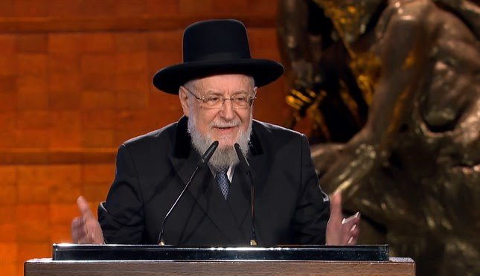

***Rav Yisrael Meir Lau, a Buchenwald concentration camp survivor and former Chief Rabbi of Israel speaking at last week’s Yad Vashem event.***

They saw that the descendants of the survivors built in Jerusalem a very modern light train that crosses the vibrant city from one end to another. The honorable visitors saw the thousands of passengers who daily take those trains to their jobs, their errands or their homes.

n Jerusalem they also saw that there are blonde Jews, brunette Jews, white Jews, and Jews of color. And that they speak French, Spanish, Russian, Ethiopian and Hebrew. They saw that millions of Jewish immigrants arrived with their suitcases to stay in the land of their ancestors, and that they are not planning to leave.

Visitors also saw that in Jerusalem the Tora is not in pieces, or burned, or in a museum. The Tora is alive. It is heard through all of the streets, corners and markets. It guides the steps, actions and thoughts of millions of citizens of Israel. And its voice resonates not in Latin but in its original Hebrew. Stronger than ever.

Commemorating the liberation of Auschwitz in Yerushalayim is a powerful message. The people of Israel are not in a museum. The Jewish nation rose from the ashes of Auschwitz and live now in the warm land that G-d had destined for His people.

*Reprinted from the January 26, 2020 email of the Shehebar Sephardic Center.*